Hawaasi Quchumi dhaggitte donna

1.Looqqe Mootimmate Mine
Looqqe mootimmate mini Hawaasi Quchumi mereerinni 6 k.m xeertinyira afamanno.minu Quchumaho wodiidi galchimi ragaanni Fiincaawu Olliira afamanno.kuni mini 1951 m.d Nugusu Hayle Sillaase Sidaamu Gashshoote daanno yannara fooliishshirara minnoonni mineeti.hatte yannara Sidaamu Gobbate Kifile (kifilehagere )gashshaanchi Raasi Desti Daamixewu minsiisinota dhagge kultanno.Minu minamino qooxeessi Hawaasi Garbi qaccera ikkasinni hee’rate ikko daa’’atate lowo geeshsha injiinoho.Minu sase kifile afirino umihu gallanniwaati layinkihu agaraano galtannowaati sayikkihuwosinu foolishshirannowaati ledoteno minu biso hayishshi’nanniwi (ganda),ixaana wiliishshinanni base afirino faayya dargaat.xaa yannara mootimmate mini Hiwooti Birhaan Kirstiyaanu Mini hundaanni galanno.

2.Kuyye Waatu Qawwe (Madife)
Madife afantannohu Kuyye Waatu Tullichiraati.Madife Hawaasi Quchumi mereerinni 6 k.m xeertinyira afantanno.Tini madife loosantinohu Ixaaliyaani gobbara 1917 I M.D Itiyoophiyu kiiro garinniiti madifete kepheepho 35 toone ikkitanna xaaliyu gobbanke layinki yannara qafade amadi waro olamaano adhite dagginota dhagge kultanno.tenne yannara yaano 1936-1943 geeshsha assinoonni olinni olaho horonsi’noonniha nafa ikkirono xaaliyu olanto qeelante gobbanke agurte fultuw waro hunte hadhinota dhagge xawissanno. Tini madife Tullote olliira afamase Sidaamu Daga Itiyoophiyu wolaphosera baatooshshe baatinota xawissanno.
3.Haranfamu Sooddiyyete KInnna
Tini kinna afantannohu Haweela Tuulate Sini Quchumi Haranfamu olliira quchumu mereerinni 13 k.m xeertinyira wodiidi soojjaati ragaanniiti.Tini kinna uurritinohu hundi yannara ikkase dhagge affino geerri kultanno. Dhagge affino geerri kultanno garinni tini kinna uurritinohu mootenna bareedda reytanno wote qaagooshsheho waammate aanaati. Wole widoonni qaalisammete sidaamu daga giddo afaminohu Dingami Koyyahu mitte anganni qasino yite ammantanno dagoomu bissa no.konni olliira afantanno sooddiyyete kinna giddo jawiidihu hojja onte meetire ikkanna hala’linye lame meetireeti.Tenne kinnara hala’lado xiinxallo hasiissannoseta ogeeyye kulte baadillicho ijaarshu (engineering) egenno xawisannori noota tittirshunni kultanno
4.Sidaamu Sumuda
Tini hawulte afantannohu Hawaasi mudukkira qullaawu gabrieeli kirstiyaanu mini albaanni piyaassu qacciraati.sumudu ijaaraminohu albi Sidaamu Zoone xaa Sidaamu Qoqqowi Gashshootinni 2003 M.D.Sumuda yaanno qaali Sidaamu Afoo ikkanna tirosino sidaamu daga malaate yaate .sumudu ijaaraminohu egenno la’nummoro moozaayki yinanni hayyonni ikkanna Sidaamu bude balchooma xawisanno garinniiti.sumudu suude la’nummoro weesete muqullichi suudinni ijaaraminota la’neemmo kowiicho xawisa hasi’noonniri weese sidaamaho qara sagale ikkasenni sa’e mayimmase xawishsha ikkitinohuraati. Sumudu hawulte aana wole la’neemmo misile Affinote Songo ofoltino geerri misile afantanno tini ma xawissanno yinummoro Sidaamu daga dagoomu mereero Kalaqantanno kiphuwa ikko dagoomitte mitiimmubba affinote halaalunni ma’le fa’le tirannota xawisatenna Sidaamu Budu Gashshooti affinote songo seerinni galannota xawisateeti. Wole sumudu aana afantanno misile Bareeda (Janna)ikkino Ejjeettichu manchi udd’irate amanyoteeti tini xawissannohu sidaamu daga bareendenna bareedda uddidhanno,seessannonna amaxxanno urde xawisateeti wole mootitte Furra misile sumudu aana sumudantino tini mootitte mitte yannara sidaama mittimmate mootitte ikkite gashshitinota qaagateeti yaano ise kawa wo’ma sidaama mittimma gashshino mootichi nookkihura ise addinni qaagantanno.
Sumudu taje
- Hojja 26 meetire
- Hala’linye (diametet)10*10meetire
- Qooxeessise hala’linye 47*47
- Giddollitte4.65 meetire
- Hawaasa Quchumi deerrinni loonsoonni hayyonni ikko jawimmasenni umite
- Baattote millimmo yanna huwachishino garinni loosantino
- Aleenni guunxosira banqo garganno uduunnicho worre loonsoonni
- 900 faawuntene noose

5.Geete Semaane Huuccattote Base( Gedaam)
Gedaame afantannohu Tullote olliira quchumu mereerishinni 5 k.m xeertinyiraati. Gedaame minantinohu Itiyoophiyu kiiro garinni 1994 M.D Abba Adelmo yinanni Kaatoolikete amma’no massagaanchinni ikkase dhagge xawissanno.Gedaame Hawaasi Garbi qooxeessira minantinohura daa’’attote ikko dhagge huwatate lowo horo noose gedaamete hoowe giddo babbaxxitino dhaggeeffachishshanno kalaqamu haqqe kurkurre minnoonni huuccattote minna afamasenni baadillicho egennonni loonsonniri noota huwachishannori no.Tini gedaame xaa yannara Hawaasi Quchumi Gashshooti Woga Turizimenna Ispoortete Biddishi dhaggete donimmanninna kalaqamu daa’’atto asse maarreekkino baseeti.
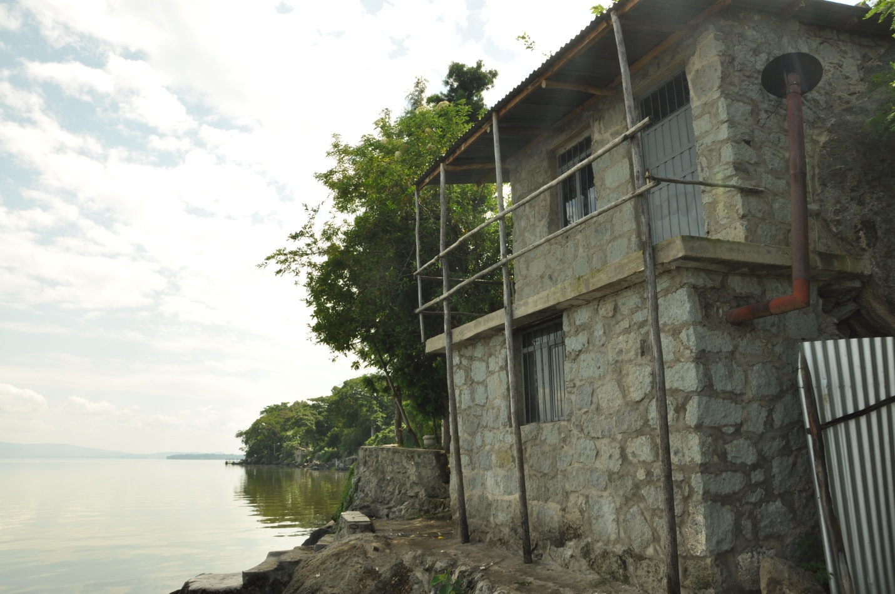

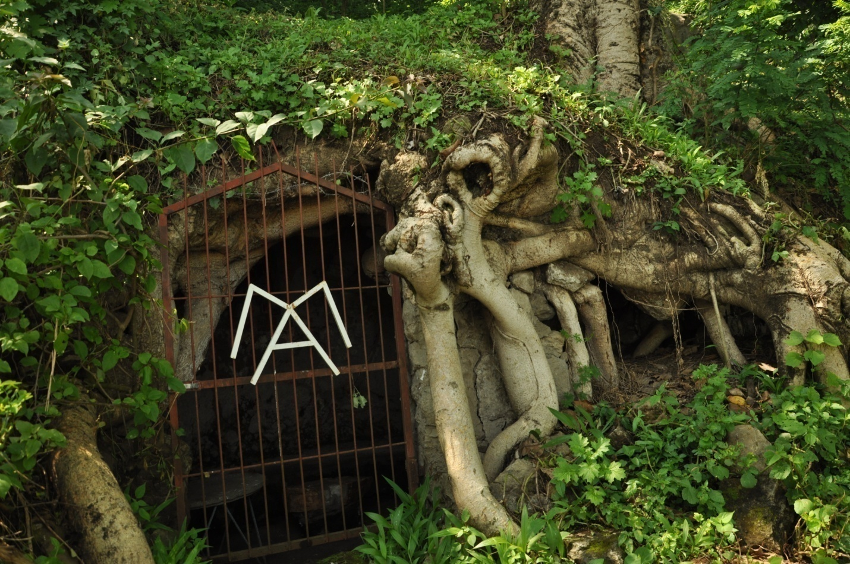

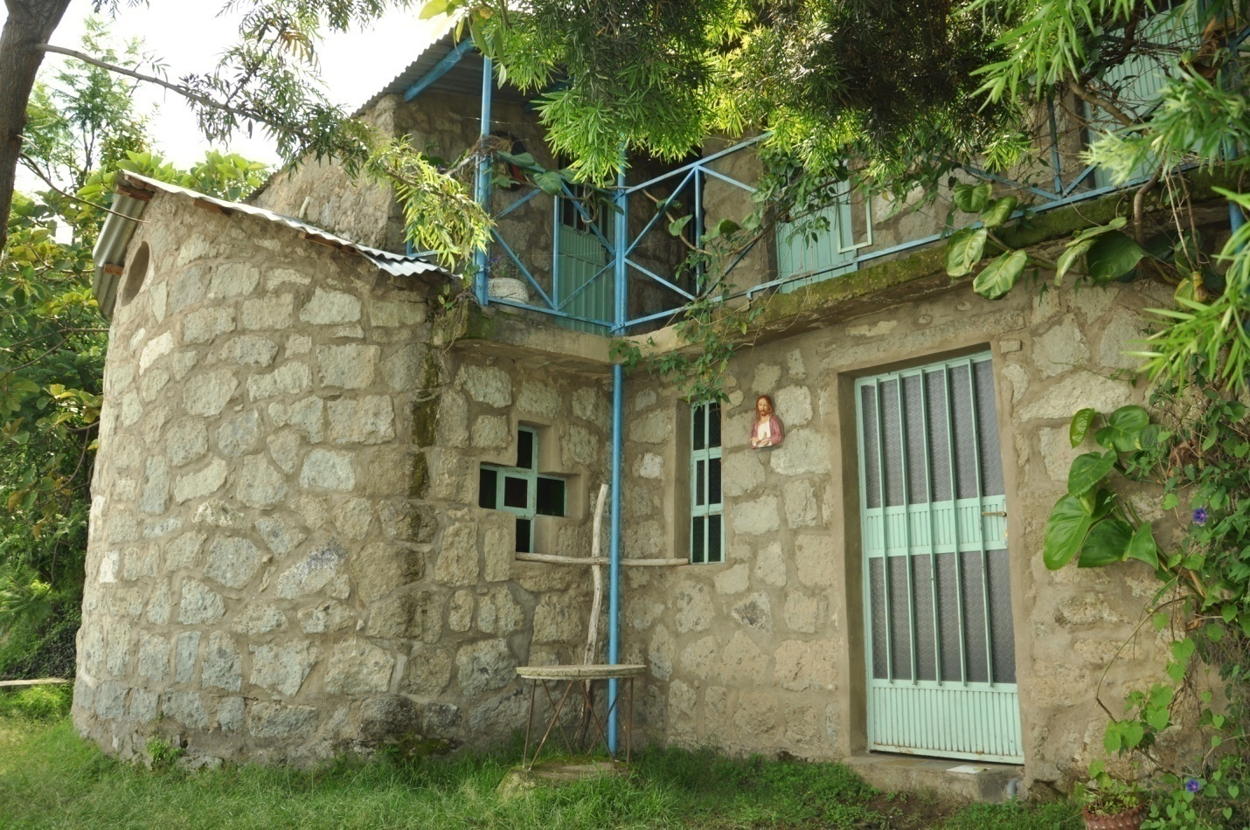

6. Sidaamu Woga Hara
Sidaamu woga hari afamannohu piyaassu qacciraati.haru minaminohu 1977M.D ikkanna sinimunna haru owaante aateeti.Haru hoowe giddo xaa yannara harunna sidaamu daga dhaggenna woga xawissanno muuzeemete owaante uytanni afantanno haru hoowe giddo sidaamu daga wolaphora kakkalantino ejjeetto sooddiyye(hawult) qaagooshsheho uurrite afantanno.Hawulte uurritinonsa ejjeetto su’ma aanino garinni tittirshunni shiqqanno:Tekilu Yota,Mengistu Hammeesso,Fiissa Ficho,Yettera Boolle,Aliito Heewano,Baallicha Worawo.ledoteno haru gidigiddi aana Mootitte Furranna Affinote Songo misille afantanno.
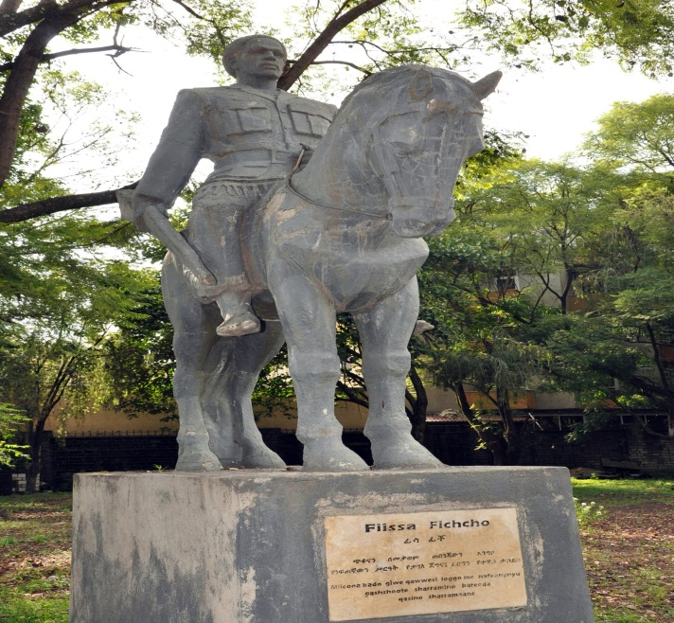

ታሪካዊ መስህቦች
የሎቄ ቤተመንግስት
ቤተ መንግስቱ የተሰራው ለንጉስ አፄ ኃይለ ስላሴ ጊዜያዊ ማረፊያነት ታስቦ ነበር፡፡ በ1949
ዓ.ም ተጀምሮ በ1951 ዓ.ም ሲጠናቀቅ በውስጡም አንድ ሰፊ ክፍልና ስድስት መካከለኛ መጠን ያላቸው የተዋቡ ሴቶችን ይዟል፡፡ የዚህ ቤተ መንግስት ትልቁ ክፍል ለመመገቢያነት ይውል ነበር፡፡ በደርግ ዘመነ መንግስት እነዚህ ክፍሎች ለገበሬዎች ህብረት ስራ ማህበር ቢሮ ሆነው ነበር፡፡ በደርግ ውድቀት ማግስት በክልሉ ኃላፊዎች ለአንድ የእምነት ተቋም የተሰጠው ይህ ስፍራ በአሁኑ ሰዓት የቤተ እምነቱ ንብረት ሆኖ ይገኛል፡፡
*የሎቄ ቤተመንግስት ፎቶግራ
የኩዩዋታ መድፍ
ከሐዋሳ ከተማ በ6 ኪሎ ሜትር ርቀት በደቡብ ምዕራብ አቅጣጫ በሚገኘው የኩዩ ዋታ ተራራ ላይ ይገኛል፡፡ ይህ መድፍ ክብደቱ እስከ 35 ቶን ሲመዘን እ.ኤ.አ በ1917 የተሰራ ነው፡፡ ጣሊያን ኢትዮጵያን በወረረበት ዘመን የጣሊያን ወታደሮች ይዘውት እንደመጡ መረጃዎች ሲያስረዱ ከ1936-1943 ዓ.ም ድረስ ሲጠቀሙበት ቆይተው ከኢትዮጵያ ወታደሮች ጋር
ዋግተው በተሸነፉ ጊዜ ሀገሪቱን ለቀው ሲሄዱ መሳሪያውን ኩዩ ዋታ ተራራ ላይ ጥለውት የሄዱት እንደሆነ መረጃዎቹ ያሳያሉ፡፡
የኩይዋታ መድፍ ፎቶግራፍ
የሀራንፋማትክልድንጋይ

በቱላ ክፍለ ከተማ ሀራንፋማ ቀበሌ በተለያዩ ቦታዎች የሚገኘው የትክል ድንጋይ ለምንና በማን እንደተሰራ የሚገልጽ መረጃ ባይኖረውም በቀድሞ ዘመን ይኖሩ የነበሩ ሰዎች ለጀግኖች መታሰቢያ በመቃብራቸው ላይ ከወጥ ድንጋይ ጠርበው እንደሚያቆሙ ይነገራል፡፡ በሃራንፋማ ቀበሌ ከሚገኙ የትክል ድንጋዮች ትልቁ 2 ሜትር ዙሪያ እና 5 ሜትር እርዝመት ያለው ነው፡፡

የሲዳማ ባህል አዳራሽ

የሲዳማ ባህል አዳራሽ በ1977 ዓ.ም በደርግ ዘመነ መንግስት የተገነባ ሲሆን ዓላማ አድርጎ የነበረውም ለሲኒማ እና ለመሰብሰቢያ አዳራሽነት እንደሆነ መረጃዎች ይጠቁማሉ፡፡ አዳራሹ በአሁን ሰዓት ለተለያዩ ሀገር አቀፋዊ ክልላዊና ከተማ አቀፍ ስብሰባዎችንና ኮንፍራንሶችን በማስተናገድ ከፍተኛ አገልግሎት እየሰጠ ይገኛል፡፡ በባህል አዳራሹ ግቢ ውስጥ ለሲዳማ ብሔር ህዝበ ዲሞክራሲ መስዋእት የሆኑ ጀግኖች ሀውልቶች በዚህ ስፍራ ለመታሰቢያነት ቆሞ የሚገኝ ሲሆን እነዚህም ተክሉ ዮታ፣ መንግስቱ ሀሜሶ፣ ፍሳ ፍቾ፣ የቴራ ቦሌ እና ባልቻ ወረቦ ይባላሉ፡፡
ፎቶግራፍ የጀግኖቹ ሰማዕታት
በባህል አዳራሹ ውስጥ የተለያዩ የሲዳማን ባህል የሚገልጹ ቁሳቁሶች ሲገኙ በመግቢያ በር ግርግዳ ላይ የንግስት ፉራና የሲዳማ ባህላዊ የዳኝነት ስርዓት የሚገልጹ ስዕሎች ይገኛሉ፡፡ ንግስት ፉራ በአንድ ወቅት በሲዳማ ህዝብ ላይ ነግሳ የነበረች ሃያል ንግስት እንደነበረች በብሔሩ ዘንድ ይነገራል፡፡
አዳራሽ እስከ 1300 ሰዎችን በሚያስተናግድ ዘመናዊ ወንበሮች የተደራጀ ሲሆን የሲዳማ ዞን ባህል ቱሪዝምና የመንግስት ኮሙኒኬሽን እጅ ይተዳደራል፡፡

የሲዳማ ሱሙዳ

የሲዳማ ሱሙዳ ሀውልት በፒያሳ ከቅ/ግብርኤል ቤተክርስቲያን ፊት ለፊት የሚገኝ ሲሆን ግንባው ተጠናቆ ለጎብኚዎች ክፍት የሆነው በ2003 ዓ.ም ነው፡፡
በእንሰት የውስጥ ክፍል /እንቡጥ/ ቅርጽ የተሰራው ይህ ሐውልት የሲዳማን ህዝበ ባህል፣ ወግና እሴት ማሳያ ሆኖ ያገለግላል፡፡ በሐውልቱ ላይ የሲዳማ አባቶች፣ ባህላዊ የዳኝነት ስርዓትን እንዲሁም የንግስት ፉራን የሚያመላክት ሲሆን ህዝቡን ሊገልጽ በሚችል መልኩ ዘመኑ በደረሰበት ውድ የዲዚያን /ሞዛይክ/ ጥበብ የፈሰሰበት ሲሆን ከ900 በላይ ፋውንቴኖች የተገጠሙለት ነው፡፡

Historical heritage

Loke Palace

It is situated 6 kilo meters south-west from Hawassa city center. It was established and inaugurated in 1951 E.C. with the presence of emperor Hailesilassie. In 1949E.C. the construction of the palace was accelerated at Loke. This palace was purposefully built as a temporary stay for the king. In 1950 the finance and materials for the construction of the palace was allocated along with enough man power and the construction was completed in 1951E.C. The palace comprises one big and six medium sized beautiful houses. The largest room of this palace was used for dinning. There was relatively large dining hall too. During the Dergue regime seven houses of the palace were offices of farmers’ cooperatives. The dining hall with additional rooms is being used as an elementary mission school at present. The palace is currently administered by Hewet Birhan Church.

Kuyowatta Cannon (Artillery):-found at kuyowatta hill around 6 kilometers away from the city center in the south-western direction. It was made in 1925and its weight is 35 tons. The cannon was brought by Italian troops during the 1945 to 1951 invasion. The troops left the artillery at the hill of kuyowatta when they were driven away from the country by the Ethiopian courageous fighters.

Haranfama Stelae
Stele is the standing stone slab used in the ancient world primarily as a grave marker but also for dedication, commemoration, and demarcation. Although the origin of the stelae is unknown, a stone slab, either decorated or undecorated, was commonly used as a tombstone, in the ancient world. According to the meaning above, commemorative stelae are the manifestation of ancients’ (people of the past) of Sidama. It is believed in Sidama culture that the dead were represented on the grave stelae as they were in life, they were as warriors, or combatants or hunters on their participation of social, economic and political affairs. The largest sized stelae (2m^{s} in diameter and 5m^{s} in height) in Haranfama, was usually used as commemorative of the earliest men. It is tall and narrow at its top and wide at its base and it has an elliptical shape. Besides to these, some few numbers of stelae are found in the area of Haranfama kebele; and cultural tukuls are found in different sites of the areas.

The Cornerstone
The cornerstone (or foundation stone) concept is derived from the first stone set in the construction of a masonry foundation, important since all other stones will be set in reference to this stone, thus determining the position of the entire structure. The foundation stone often has a cavity into which is placed a time capsule containing correspondents of that specific and projected job of the ceremony plus other artifacts that are typical of the period of the declaration to done that specific work. During 1968, King HaileSilasie has placed a foundation stone on Meskel Square to carry out the shifting of the capital city of “Sidamo” province from Yirgalem to Hawassa, with the King's name and official position and the date usually being recorded on the stone. The shape of the stone is rectangular and is made from a single big stone.

Sidama Cultural Hall
It was inaugurated in 1977 E.C during Durgue regime to give various services. This cultural hall was built to serve as Cinema and conference hall for the residence of the city. Currently, the hall has been administrated by Sidama Region Culture and Tourism bureau. In the compound statues (monuments) are erected near to the main get. The statues have been erected for the memory of Sidama patriots who fought for the right, freedom and democracy of the Sidama people. The memorable heroes among the Sidama were: - Alito Hewano, TekluYota, Mengistu Hameso, Fisa Ficho, Yetera Bole and Balicha Werawo.

Within the compound there is Sidama cultural house. This house includes some cultural objects. On the wall of the hall there is picture of Queen Fura. Fura was a highly respected queen of the Sidama. It is believed that Fura had major role for Sidama women. In addition, there is also another picture which shows the general assembly of Sidama elder’s songo. In addition there is cultural meuseum.
The Sidama cultural hall has been well equipped with modern seats, with offices, shops, and other services. Today the hall constitutes 1500 seats.

The statue of Sidaama Nation “Sidaamu Sumuda”
“SidaamuSumuda” is a statue of the Sidama nation which is located in front of St. Gabriel Church; in the midst of a square. One can easily notice the statue while traveling from piazza to the church; or can be seen at a distant position. The statue is built by Sidama region administration so as to reveal historical and cultural heritages through it.
“SidaamuSumuda” is the name given to the statue is Sidaamu Afoo; which means ‘Identity Sidaama Nation’. It is also called because some of the major cultural and historical heritages of the nation are signified through the mosaic portraits and the overall design of the statue. These can be identified while observing the statue from different angles.
Descriptive (Special features)
The ‘Sidaamu Sumuda’ statue is differently special in its appearance and overall aspects. Some of these are:-
- It illustrates the originating and true identity of the Sidaama nation at once.
- It is built with the latest art of mosaic technology. This makes it the second to be built with this technology next to the statue of Mexico in Addis Abeba.
- It is one of the few tallest statues of the country which possess a maximum height.
It is an aesthetically advanced statue of its kind through the country. The fountains falling from and around the statue have added to its aesthetic value.

The monastery of “Gete Semani”, and its surroundings
A monastery is a special place set aside for meditating and emptying out the clutter of thoughts that can cause a person's mind to become muddled. Monasteries are buildings that house monks or nuns of a certain denomination but are also open generally to visitors to rest or pray. Monasteries exist in Christian cultures but are also found in Buddhism and Hinduism. In the Roman Catholic religion and to some extent in certain other branches of Christianity, there is a somewhat more specific definition of the term.
The monastery of “Gete Semani” is located in the south west direction, 5km away from the city in a special place called “kuyuwata”; which is a mountainous structure situated at “tulo” kebele.
It is believed that the monastery was established by a catholic priest named Father Adelmo in march 1994 EC; and have been serving as an ideal place to pray and carryout other religious practices for both local and foreign catholic religion followers. Moreover; being situated at the shore of Lake Hawassa, the monastery is full of natural beauty that it plays a major role as one of a tourist attraction sites of the city.
In addition to that; the monastery is situated in a mountainous structure that it allows one to have a great view of the city and the surrounding natural beauty.
The internal aspect of the monastery is of a great wonder by itself. In addition to having one worship section, there are three rock hewn sections which are one story high each. The monastery is built in such an environmental friendly way that its architectural aspect is one of a great kind.
In addition to that the two manmade caves which are built below two oak trees next to the monastery have added its value as a major attraction site in the city. Besides, the complete silence surrounding the area makes it to be one of a favorite place for religious purposes.
Lately, a number of development and investments activities have been carried out around the monastery and its surrounding area. Some of which include; a pig ranch, cultural lodge and an environmental protection projects such as afforesting the area with environmental friendly and native tree specious.
The monastery is located short distance away from “Loke, Bushilo” clinic that one can visit the area without any difficulty. The other, but worth mentioning aspect of the area is that it is full of different bird specious, making it favorable for different sanctuary activities. A flock of aquatic specious such as alligators (Arjano) can also be observed at a near distance from the monastery.

Wogate Ayyannanna

FICHEE CAMBALAALLA
- Sidaamu daga diru soorro ayyaanaati
- Kalqete deerriy lamu dani diru kiirishshi (calandar)afamanno insano arrishshote kiirishshanna aganunna beeddahete kiirishshaati.
- Sidaamu daga diru kiirishshi xintaminoh aganunna beeddahete millimmonniiti
- Sidaamu daga fichee cambalaallate ayyaana ayirrisa hanaffunkunni dirra kiirantinota geerru xawissanno.
- Sidaamu daga kalaqantunku diro kiirate egenno noose dagaati.ikkinohura fichee sidaamu daga kalaqante dagoomitte heeshsho hanaffu yannaraati yite ammantanno geerrinna ayyaanto no
- Wole widoonni ficho yinanni mancho ledo amadisiisse hanafantinota xawissanno geerri no.Tini mancho diro kiirte qawaadi barra buurisame qishidhe roduuwasenna qarqaru manna gamba assite itissanni keeshshitu gedensoonni mitto diro daggukki gattanno tenne huluullantino roduuwise xa’misiissanno wote reytinota kullanninsa rewose macciishshitino roduuwise ise qaaggora diro kiirte qawaadi barra buurisame qishshe qarqaru manna woshshite itisa hanaffu gedensoonniiti ayirrisa hananfoonnihu yite ammantanno

usura
- Annuwu geerru ficheete aganu gatanno yannara gobbate huuccitanninna aagintabbanni qatuminte hosse hawarro ittanno.
- Usura e’annori geerraho,cimeeyyete,mootete,geelotenna ayyaantote
lallawa
- Ayyaanto barra kiirte agananna beeddahete millimmo heesssagge ficheete barra murte mootete kultanno. Sidaamu daga lamalate barrubba ontete qawaado,qawaallanka,dikkonna deelaho qolte qawaado yite dagganno
- Diru 12 agana afirino mittu mittunku agani 28 barra afirino sidaamu barrubba danchanna busha yee beehanno ledoteno 14 barrubba agana yee badanno qoleno14 barrubba tunsicho yee gaamanno su’mansano aanino garinni,tittirshunni,shiqanno,Argaajima,Arba,Bolla,BasaAma,BasaBeetto,Caroowa,Dureette,DullaatteBeetto,Bidirsa,DeetteBeetto,Karaawicha,Gardaaduma,Sonsa,Rurruma,Lumaasa,Gidaada,Ruuda,EreerteAma,EreerteBeetto,Adula Ama, AAdula BeettoHarfatto,Deette Ama,Dullatte Ama,Bita,Ciicho,Sorsanna Lao yinanni.
- Mooteno ficheete honsu barri gate hee’reenna gerechu lande sutte qawaadi gudumaalira lallabbanno
Lallawu amado
Tayxe Fichee techo honse qawaado hossannohura
- Giwammohu araaramo …!!
- Caacco noohu guxxi..!
- Qege noohu fiici’ri..!
- Maalu mine galoonke..!
- Haqqa murroonke ..!
- Koffeeny hee’roonke..!
- Haaru diri keeru keeraatunniha ikko!

Qeexaala
- Safote qeexaala usura guxxitino geerri woy cimeeyye fichee rahase xawisate gudumaaleho balaxxe qeexa’litanno qeexaalaati.
- Ficheete umi qeexaalaati.
- Addicha qeexaala ficheete sasu barri gate hee’reenna wedellu foniinsata xawissanno qeexaalati
AYYAANU AYIRRISHSHA
- Umi barri fiixaari barraati
- Qawaadi soodo geerru gudumaaleho gerecho gorrite hellee la’e diro masaaltanno
- Gudumaaleho baalu noowa hulluuqa qanse hulluunqanni
- Hawarro qae qaentera hulluuqa qanseenna maate baalantinna saada hulluuqqanno
HULLUUQU AMURAATE
- Maate baalantinna saada hulluuqqanno
- Umo annu,amanna ooso dirinsa deerrinni goofimarchoho saada hulluuqqanno
- Shamu haqqinni qansanni
- Hulluuqu mereero hayisso worranni konne assinannihu diru danchummanniha ikkara halchinannihuraati
- Waate waateho giira qansanni akkalu diri babbaxxino qarrinni fulloonnita xawisateeti.
- Hulluuqa dooramina haqqinni lawishshaho leemmunni leemmu nookkiwa wolu danchu haqqinni qansanni
- Hulluunqanni yannara togo yaanni hulluuqanni
- Busha badhera higge gati
- Buxima badhera higge gati haaro diro sa’ooti
- Baashe,rewo badhera higge gati yaanni hulluuqanno

- Xaphooma hulluuqu tiro akkalu dirinni sa’’ate malaateeti.
SHAAFEETU AMANYOOTE
Hulluuqu amanyooti gedensoonni shaafeeta intanni.
- Shaafeeta intanni amanyoote jawu qaera hananfanni
- Shaafeeta baalu mitteenni gamba yee anga mittee wore itanno
- Shaafeetu taaloonyunna mittimmate malaateeti korkaatuno anga mitteenni taalo massinannihura
- Fichee dirunni diro iillishinke yinanni intanni
- Fiixaari hawarro jawu qaera hananfoonni shaafeeta itate amanyoote mine mine doynanni intanni gallanni

CAMBALAALLA
Sidaamu daga diru kiirishshi garinni lamalate giddo shoole barrubba no insano; qawaado,qawaallanka,dikkonna deelaho wirro qawaado yee kiiramanno
- Kuri barrubba giddo diroho umi barri fichee hossannohu qawaadoho layinki barri cambalaalla hossanno barri qawaallankaho.
- Ooso soodo iibbino wayinni alba hayishshidhenna buuro buudhite ayidde cambalaalla yitanni ayidduno iille iille yaanni buurisame itisanni hosanna
- Annuwu kalote boole worte saada qawaaxxisse hossanno
SHAASHIIGU AMANYOOTE
- Cambalaalla sa’u gedensoonni sayikkita qeexaa’linanni qeexaala shaashiiga yinanni.
- Fichee qeexaalunni,horetenna faarote iibbitanno

FICHII FULO
- Cambalaalla sa’u gedensoonni lame lamala geeshsha sidaami giddo afantanno babbaxxitino sooreessu gudumaallara qeexaa’linanni ayirrinsanni.
- Fichii fulote qeexaa’linanni qeexaala gilbete qeexaala yinanni
- Konni qeexaalira idaaycho ballose ledo gedumaale fultenno
- Xiddu noohu guxxe gudumaale fulanno barraati
- Wedellu baxxinotera fiqiicho uydhanno yannaati
FICHEENNA QEEXAALA
Sidaamu daga qeexaa’litannohu babbaxxino korinniiti insano:
1.ficheete
2.mootimma adhituronna gibburo
3.wosina adhate
4.moote somintanno wote
5.mootetenna jajjabbu wi’lara

Fichee ayirrinsanni amanyooti giddo mittunna jawu amanyooti qeexaalaho.

Umi qeexaala SAFOTE QEEXAALA yinanni
- kuni qeexaali usura e’ino geerri usuransa gudde ficheete honsu barri gatanno wote fichee rahase xawisate lallawu gedensoonni qeexaa’linanniho.

- Layinkihu ADDICHA QEEXAALA

- Wedellu qeexaa’lanno

- Foniinsata xawisse qeexaa’litanno

- Ficheete sasu barri gate hee’reenna qeexaa’linanni

Sayikkihu SHAASHIIGA QEEXAALA
Cambalaalla sa’eenna sayikki barra qeexaa’linanniho.
- Shoolkihu GILBETE QEEXAALA
- Kuni qeexaali fichii fulote qeexaa’linanniho
- Konne qeexaala sooreessu gudumaalira qeexaa’linanni
- Idiyaacho ballose ledo ikkite gudumaale fultannoho
- Xiddu noohu xiddasi guxxe gudumaale fulannoh

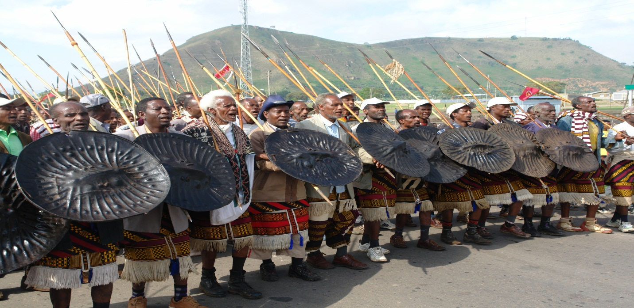

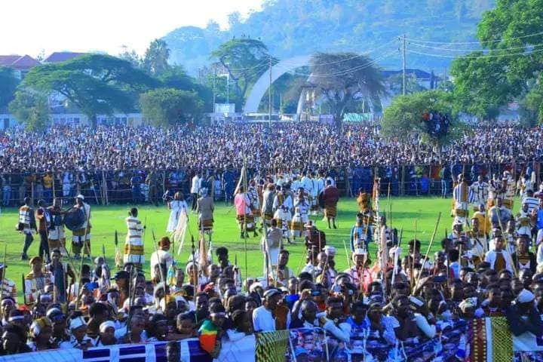

FICHEETE HORNYUBBA
- Araarunniho
- Mittimmanniho
- Haqqa dimurranniho
- Saada digorrinanniho
- Ooso hagiidhitanni qoossonsa cambalaallitanni hossannoho
- Maala di’’intannih
Affinote songo(sidaamu daga kipho tirranninna galtinote amanyoote)
Sidaamu daga dagoomu mereero kalaqantanno kiphuwa tirtanno doogo affinoteeti.Affinote songo ofoltanno darga gudumaale yinanni.songote deerru noose Nafari Songo,Olluu Songo,Ayiddu Songo,Mootete Songo yine beenkanni.songote giddo aliiditi Mootete songooti. Budu gashshootu amanyooti seeri garinni sidaamu falannohunna malannohu gudumaalu songonniiti konni daafira songote amanyooti budu gashshooti bisooti.Tini songo massagantannohu cimeeyyete,mootete,garote,geeloteet.Affino yitanno hedo mimmito macciishshate dimokiraasitte amuraateeti. Affinote amanyooti garinni mittu callu gumulo saysate kaayyo nookkihura halaalu fulate sae giwansho kalaqantu lamenka fiixa araarsatenna koma ajishate jawa qeechi fulanno.Affinote songora hajajamannokkihura seera worronnihura songote gumulo ayirrinsanni.Hawaasi Quchumi giddo tini affinote songo ofoltanno gudumaalla babbaxxitino olluubbara afantanno insano Tullu,Daato Odahe,Gamaxo,Gaara Riiqata,Allamuru Baarangu gudumaallaati.tenne gudumaallara lamalate lame higge songo ofolte babbaxxitino dagoomu giddo kalaqantanno kiphuwanna sumumme hoogate hajo falte,malte gumulo sayissanni afantanno.tenne gudumaalla giddo Tullote Gudumaali songo aliidi deerrinni tantanamino gare gudumaaleeti.Tenne gudumaalla giddo baattote buuxishshi woraqata afidhinoti Tullonna Daate Odahu Gudumaallaati.

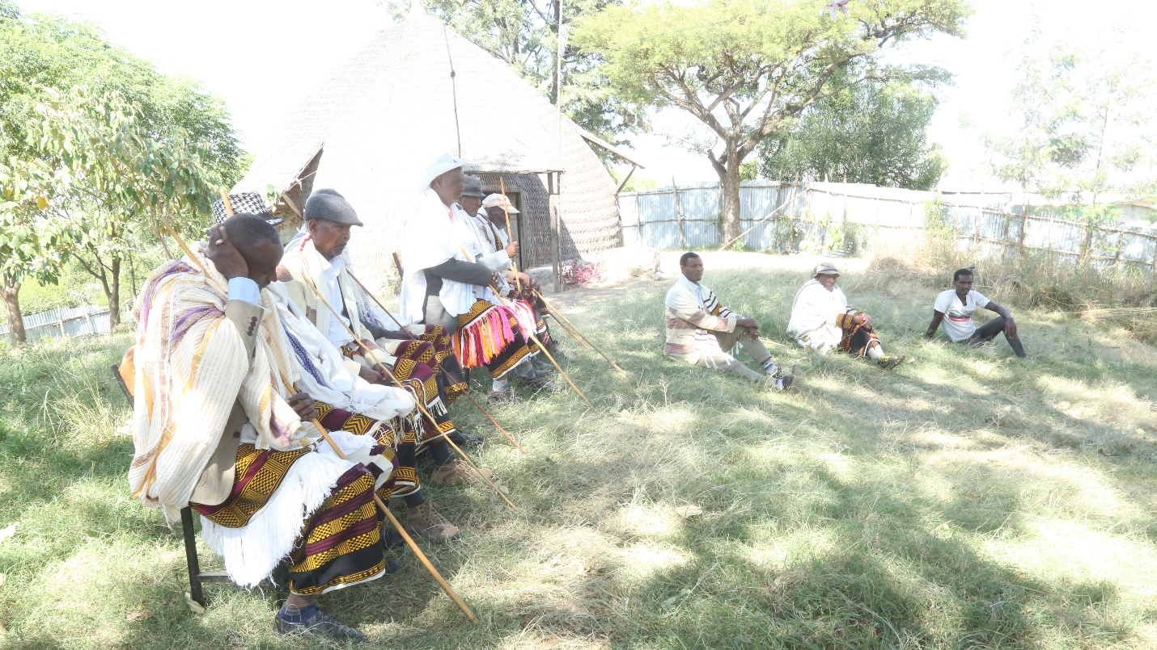

Traditional festival
Fiche chambalala
The sidama nation has its own New Year so called Fiche. It will be celebrated for two weeks colorfully every year. The sidama have their own calendar which a week has five days and a month twenty eight days.
Fiche dose not fall on the same day every year but it falls on “Qawado”, the first day of the week. The day is determined by elders who practice astrology and announce it to the communities. Fiche is commonly celebrated at Gudumale on the shore of the lake Hawassa where thousands of sidama and people from other ethnic group gathered and celebrate together.
At the evening of Fiche, each fresh family head makes "huluqa” (arch) from fresh woods in front of the house and makes every members of the family, even the cattle, pass through it. This is done to symbolize the transition process. During the night of the holiday, People of the village gather around in one of the village’s elder people and have cultural meals together.

In the next day after Fiche is called Cambalala. On this day the family head shall wear his traditional custom and shall feed his cattle in “kalo” (protected pasture area) by sparking ‘bole’ salty soil and pass the day feeding and looking after them. This ceremony has healed in the city of hawassa near to Lewi Resort on the places called Gudumale once a year.

Luwa System:- Cultural institution in Sidama in which male members of the community make participations to get social status, social rank, and transition to efficient elder ; furthermore it is an institution in which each male gives defense service through luwa participation. This attractive activity is done in the cultural Sidama villages surrounding the city.

Traditional Judiciary System of Sidama People.(AFFINO)

The alternative dispute resolution is practiced in many nations and nationalities in Ethiopia, amongst Sidama are one of the nations which practices transitional alternative dispute resolution.

The place where the activity takes place is called Gudumaale, which are structured in hierarchical chain of power. The cases submitted to the tribunal are dealt with depending on their magnitude. The tribunal begins step by step move to process of forgiving judgment.
The judiciary system reduces and discourages criminal acts in a strategic and artistic way; and it avoids unnecessary bloodshed. It quarrel arises among individuals; or conflicts happen between clans, or if any incidents that may cause blood shedding are come about, they all get solution and just judgments by the tribunal of the shongo, where there is justice, peace prevails. If there is anyone who desire to visit this traditional judiciary system may come and visit tullo and daato odahe.

